New Items in our Bargain Basement
We have recently acquired a substantial selection of used, second-hand equipment, tools and materials. They have all been uploaded to our web site and are now available for immediate purchase on a first-come-first-serve basis. These items will sell quickly, so please do not delay in visiting our Bargain Basement.

Contents
Tools
Hand Tools, Pallets, Decorative Wheels
Fillets and General Bookbinding Tools
Books | 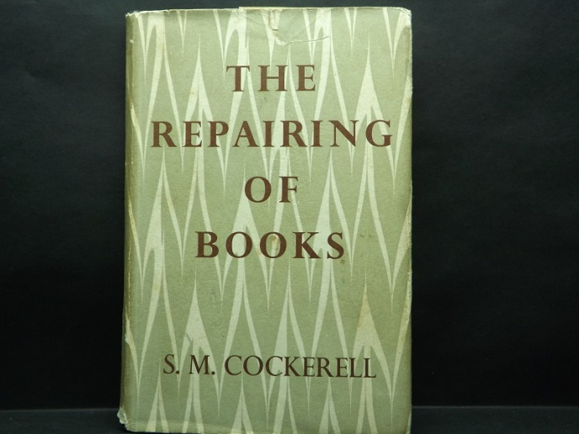
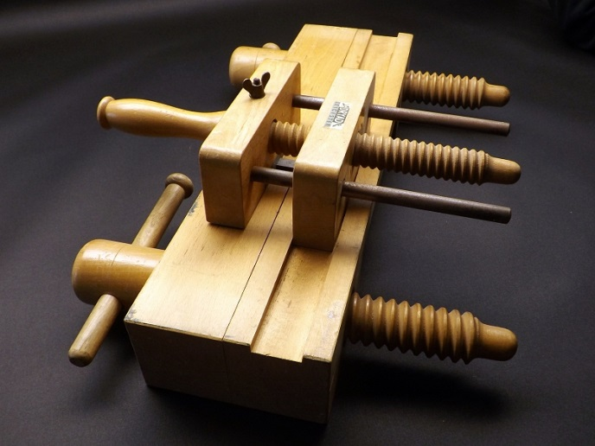 | Equipment  Litho Stones, Wooden Equipment
Papers
Marble and Plain
Leather
Special Offer and Discontinued lines

from David Lanning and all the team at J Hewit & Sons

Our mailing address is:
J Hewit & Sons Ltd.
12 Nettlehill Road
Houstoun Industrial Estate
Livingston, West Lothian EH54 5DL
United Kingdom

